DSA1002 2020 T3 FINAL EXAM
Muhammad Naufal Al Ghifari
90019280

Question 1
A. a). Heap tree is very good for priority based list of tasks, O(1) retrieval time for the highest priority, and even when looking for a task inside the tree for removal purposes, it will be a O(log N).
A. b). All tasks will be added to the lowest node of the tree, and then trickle it up the tree to find its place. Retrieval time for highest priority is O(1) because it Is simply the root, and finding a certain node in the tree would be O(log N) due to its tree arrangement.

B. The ADT uses names as key, names have a low chance to be duplicates, so having duplicate keys is probably not an issue here. We can use a BST, a Heap, or a hash table. Both BST and Heap usually has an access time of O(Log N), hash table however is close to O(1) (may vary due to load factor) So Hash table seems to be a good choice here.

Question 2
A. I would definitely not use merge sort as it is the worst to use in a low memory environment due to the extra array (tempArray) it requires. Some good choices would be bubble, insertion and selection. Although in place like the three others, quicksort might not be a good choice due to its recursive behaviour. Bubble usually does too many swaps compared to insertion, so insertion would be chosen here (both of these are inplace and stable).
B. 3 Median is certainly a very reliable pivot for quicksort, giving the same reliable pivot which does not happen with random pivot although quicker. With 3 median on average we will get a complexity of O(N log N) which is fine especially compared to random which potentially lead to O(N^2) when using a bad pivot.
C. The biggest concern with recursion-based functions in general is the limit of recursion or worst, stack overflow. In python there’s a limit to avoid stack overflow and this limit is quite low leading to recursion limit hit error quite often. This can be mitigated by raising the limit. If memory and recursion limit not an issue, mergesort and quicksort are both very good in general.

D. def findApple(fruits): # assuming fruits is an array
for i in fruits:
if fruits[i] == ‘Apple’:
print (‘Found the apple!’)
else:
print (‘Not an apple’)
E. We can just remove the else statement and print out the array item number which is an apple: print (‘Found the apple!: ’, i) although it will remove 1 operation if the fruit is not an apple, this would not impact time complexity in a significant manner because the biggest factor of time complexity here is the for loop.

Question 3
A. There is certainly differences when using array and linked list. The most important is flexibility: linked list can shrink and grow dynamically, an array cannot. However, for the same operation, a linkedlist requires more memory than an array so in low memory environment, an array is preferable.
B. It is not necessary to use double ended for a queue, however it is highly recommended because we need to add an item to the end of the list. In a single ended, we need to iterate through the whole list to find the last item O(N), in a double ended this is an O(1) operation because there is a tail node.
C.
def __iter__(self):
self._cur = self._head
while self._cur != None:
yield self._cur._value
self._cur = self._cur._prev

def __prev__(self):
curVal = None
if self._cur == None:
raise StopIteration
else:
curVal = self._cur._value
self._cur = self._cur._prev
return curVal

Question 4
A.
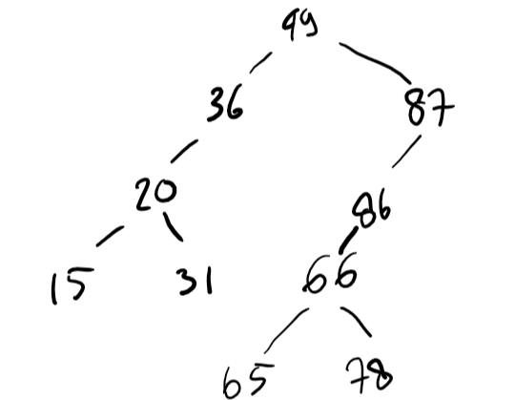

B.
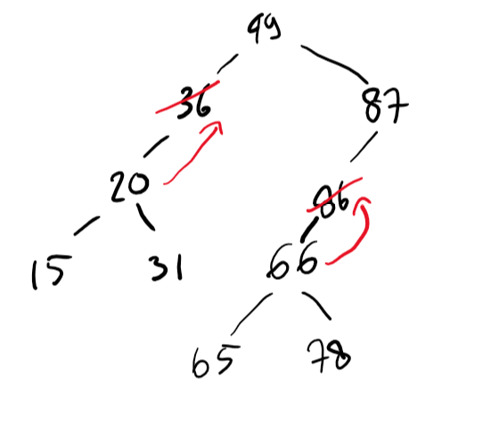
First, we remove the specific nodes: 36, and because it only has one child, this child would be “adopted” by 36’s parent node. Same logic applies for 86.
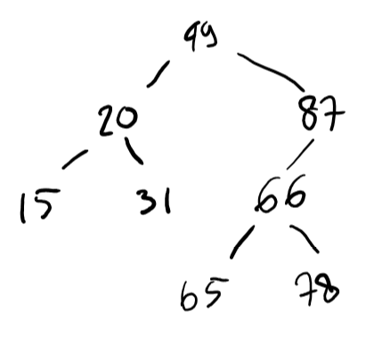
C. The 2-3-4 Tree
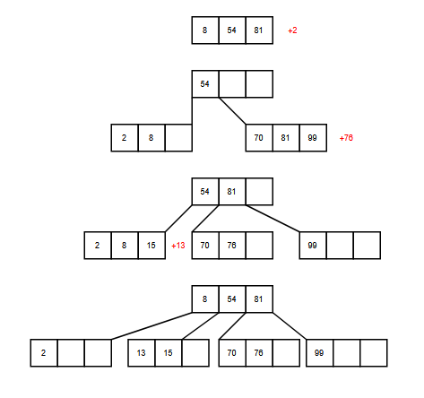
D. Converted into a Red Black Tree
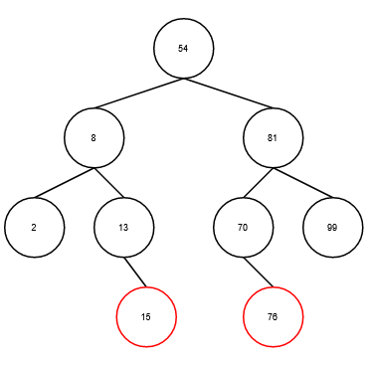

E. The logic is to make a search to the right child of the root, and then have 2 variables named latest, and secondLast. With each comparison if there is a new latest, the value of the old latest would be passed to secondLast and the function would need to export secondLast when it is finished.

Question 5
A. Adjacency Matrix
 | P | A | X | Q | C | N | K
P | 0 | 1 | 0 | 0 | 0 | 0 | 0
A | 1 | 0 | 1 | 0 | 1 | 0 | 0
X | 0 | 1 | 0 | 1 | 0 | 1 | 0
Q | 0 | 0 | 1 | 0 | 0 | 0 | 0
C | 0 | 1 | 0 | 0 | 0 | 1 | 1
N | 0 | 0 | 1 | 0 | 1 | 0 | 0
K | 0 | 0 | 0 | 0 | 1 | 0 | 0

B. Adjacency List
P: (A)
A: (P, X)
X: (A, N, Q)
Q: (X)
C: (A, N, K)
N: (C, X)
K: (C)

C. Depth First Search Output: (A, P, C, K, N, X, Q)
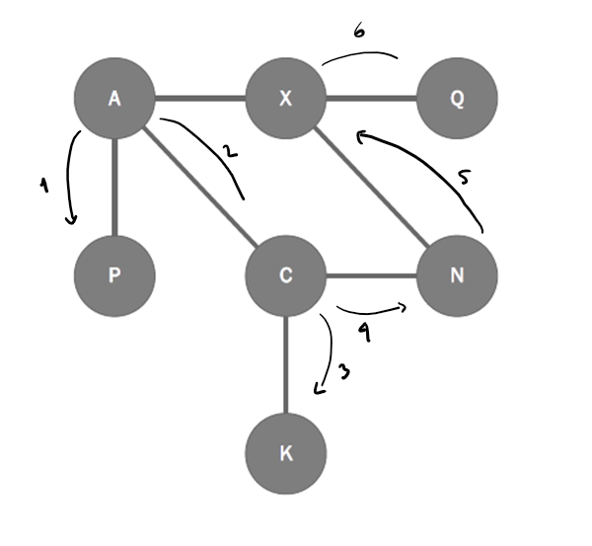

D. Breadth First Search Output: (A, P, C, X, K, N, Q)
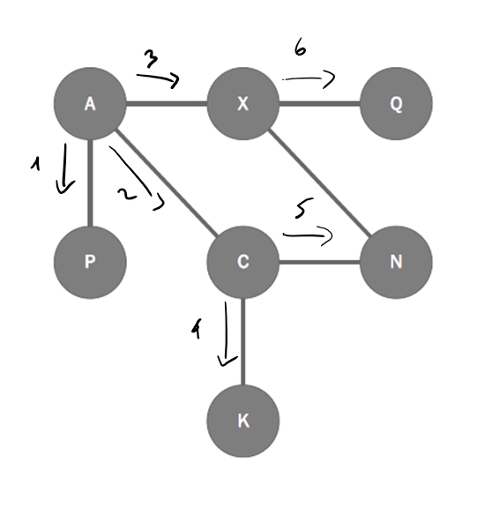
Question 6
A. Heap tree construction
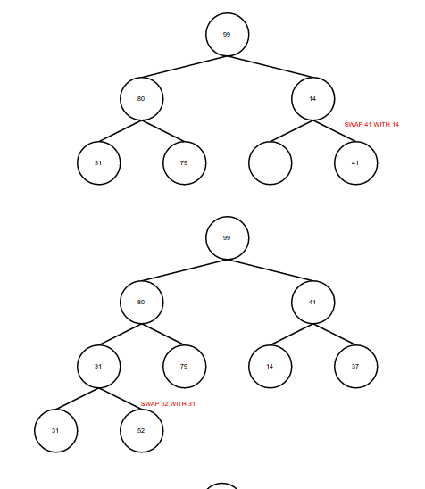
41
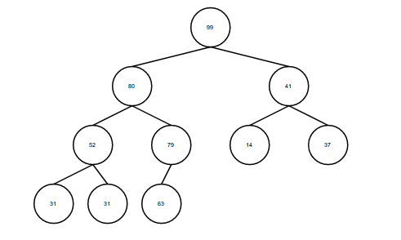

B. Heap array representation: (99, 80, 41, 52, 79, 14, 37, 31, 31, 63)
C. Put 8 it as right child of 79, so the array would be: (99, 80, 41, 52, 79, 14, 37, 31, 31, 63, 8)
D. A heap tree is very good for priority queues as the highest value is always the root so to retrieve the highest value, we just need to take the root and then find a successor by taking the smallest node and trickle it all the way down.

Question 7
A. Hash Table
 | key | value
0
1 | 1 | “Apple”
2
3 | 23 | “Cherry”
4 | *Collided with 3 43 | “Orange”
5 | *Collided with 4 964 | “Banana”
6 | 356 | “Pear”
7
8
9

B. The hash function combined with linear probing lead to one big cluster which will lead to even more collisions which is basically a vicious cycle. Quadratic probing will divide clusters into smaller clusters, although still clusters. Separate chaining uses linked list to store the key when a collision occurs, a quite different method, more than one key is stored at the same array position.
C. Use a better hashing function, a good hash function is consistently giving the same hashed key for a key, fast, distributes evenly and returns index that is sure to fit in the array.

